(Xiaoqi farm)

Xiaoqi farm is a resort which tourists can come visit the farm, buy some fresh products and even try some special dishes made of those products. This season, Xiaoqi offers two special products ‘extracted lard oil’, ‘lean pork’, and one special dish ‘slow cooked pork’. Xiaoqi can sell up to 2000 small bottles(20oz per bottle) of extracted lard oil, 2500 lb of lean pork, and 800 dishes. Each slow cooked pork dish uses 2 bottles of oil and 3 lb of lean pork, it also requires $5 for cooking. There are two kinds of pigs in Xiaoqi’s farm: white pig and black pig. Oil and lean pork are produced from either white or black pig. It costs $6 to feed one white pig until it can be made to products, one white pig can produce 2 bottles of oil and 3 lb of lean pork. It costs $3 to feed one black pig, one black pig can produce 1 bottles of oil and 2 lb of lean pork. The unit price for oil is $5, lean pork is $4, and dish is $25. The quality level of these three products are oil, 8, lean pork,7, slow cooked pork 6. The average units sold must be at least 7. Determine how to maximize Xiaoqi’s profit.

**Discussion: -**

Please refer to the photo given below. We can understand from problem that Xiaoqi farm produces three products in two steps. In first step it produces oil and lean pork using white and black pigs, and in second step it used oil and lean pork to produce dishes.

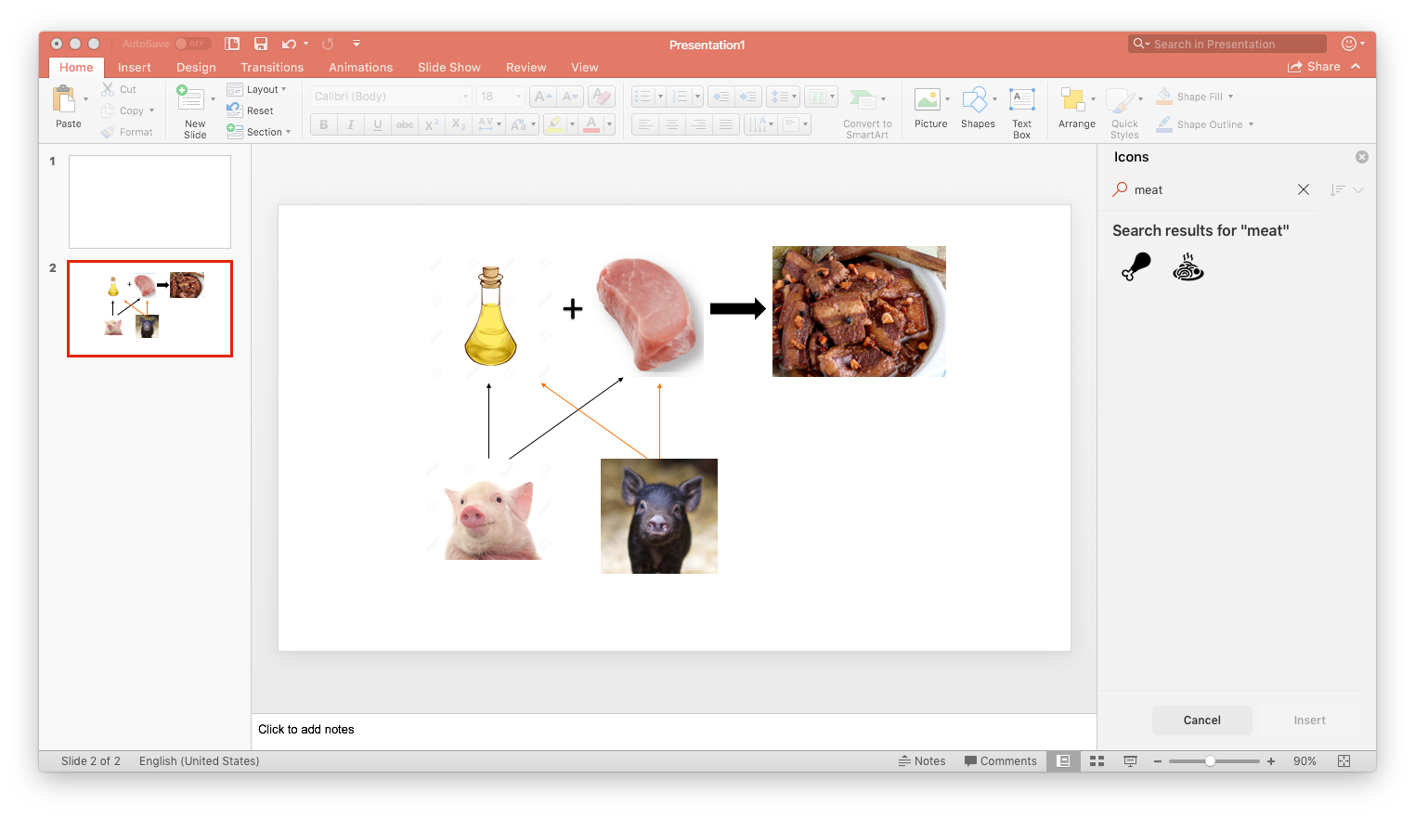

Our objective is to maximize the profit, which means we need to know how many products were sold by Xiaoqi. In order to find the production quantity, we need to know the amount of pigs used to produce that particular product. So, we should consider amount of pigs used for production of oil and lean pork, how many dishes produced as decision variables.